Resistivity Data

General
Resistivity is a useful technique for looking at the variation of resistivity with depth. It has been widely applied in Africa, particularly in basement areas. There are two main survey techniques: the Schlumberger and Wenner arrays. A modification of the Wenner, called the Offset Wenner, is particularly useful. However, in Oju and Obi, the resistivity survey is not as useful as an EM34 survey. Resurveying with EM34 at 40 m spacings gives nearly as much information as a simple resistivity survey and is much easier to carry out. The purpose of this sheet is not to describe in detail how to carry out resistivity surveys, but to help interpret them if someone else has done them.

Theory
Ground resistivity is measured by passing an electrical current through the ground and measuring the potential difference between two points. Ohms law is then used to calculate the resistance. The resistance is then multiplied by a geometric factor (normally called a K factor) to calculate resistivity.
To carry out a depth sounding (VES), electrodes are expanded about a single point. When the electrode spacing is far apart, the electric currents pass deeper into the ground and are therefore measuring the resistance deeper into the ground. A depth sounding tells you information only about one point (the midpoint of the survey). The technique assumes that there are no large lateral variations in the rock type.

Good points and bad points
Resistivity good points | Resistivity bad points
It can identify layers of different resistivity (in other words changes with depth).  It can penetrate deep into the ground.  It is not affected by tin roofs etc. | Very susceptible to bad electrode connections.  Difficult to interpret  Laborious and slow.  It only takes a reading at one point

Some tips for carrying out a survey
1. Choose an area for the inner electrodes that looks fairly homogeneous.
2. Always make sure the battery is fully charged and carry a spare.
3. Make sure the electrodes are hammered well into the ground and water them. At large electrode spacings a salt solution can be used.
4. For small electrode spacings a small current should be used (< 5 mA). Check that the resistivity is roughly the same at several current settings. If the current is too low, readings will vary.
5. At larger electrode spacings, higher currents are required since they have farther to travel.
6. Plotting the data as you go along allows you to see if any readings are anomalous. A resistivity curve should always look quite smooth.

Interpreting the data

IMPORTANT
Resistivity is the inverse of conductivity. Resistivity in Ohm-m is related to conductivity (in mmhos/m) by the formulas:
Resistivity = 1000 / (conductivity)
Conductivity = 1000 / (resistivity)
Resistivity data is interpreted by plotting the apparent resistivity against electrode spacing on a log-log scale. This should produce a smooth curve. For a Schlumberger array, the curve will be in several segments. These can be combined into one smooth curve, by using the crossover points. Starting with the right-hand segment, move it down to match the cross over points of the segment to the left. Repeat the process (always moving the right-hand segment to meet the left-hand one) until you have one smooth curve (‘Field Geophysics’ page 89).

Readings at large electrode spacings refer to the resistivity at depth. Refer to the BGS final report and the individual data reports for the interpretation of resistivity curves for Oju and Obi. Resistivity curves produced from Schlumberger and Offset Wenner arrays at the same site will be roughly similar.

Some resistivity curves with example interpretations.
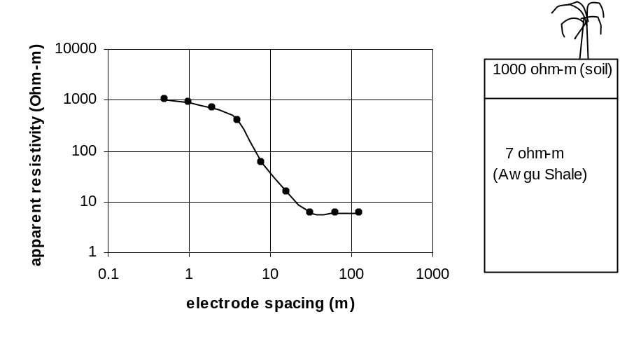

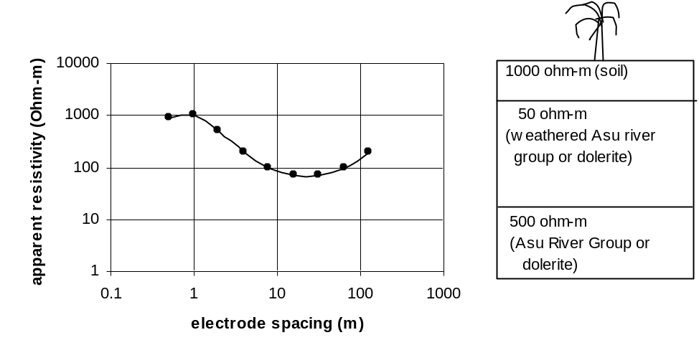
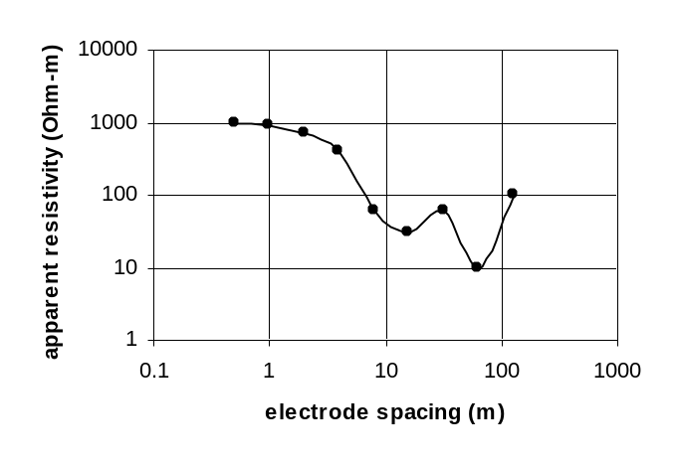
Curve is not smooth. Data beyond 10 m electrode spacing are subject to large errors probably because of bad electrode contact. Do not attempt to analyse. Repeat with EM34 with 40-m coil separations.
For these examples, EM34 with 40-m coil spacings would have given the same information. For example Awgu shale at depth will show high conductivity with 40-m separations (e.g 100 mmhos/m). Dolerite at depth will give low conductivity with 40-m coil separations (e.g. 30 mmhos/m). See BGS final report and data reports for Ugbodum and Itogo for further examples.
Alan MacDonald
British Geological Survey
amm@bgs.ac.uk

